0.-NUMBERS
- Display the even numbers from 0 to 50
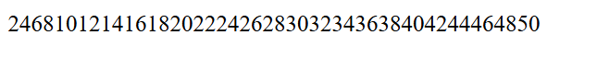
- Repeat the process separating the numbers
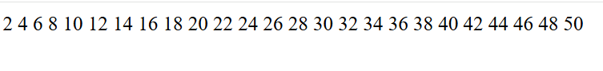
- Repeat the process with 5 numbers per row
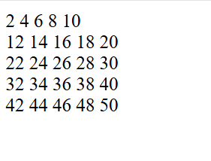
- Locate the numbers inside a table maintaining the HTML and CSS
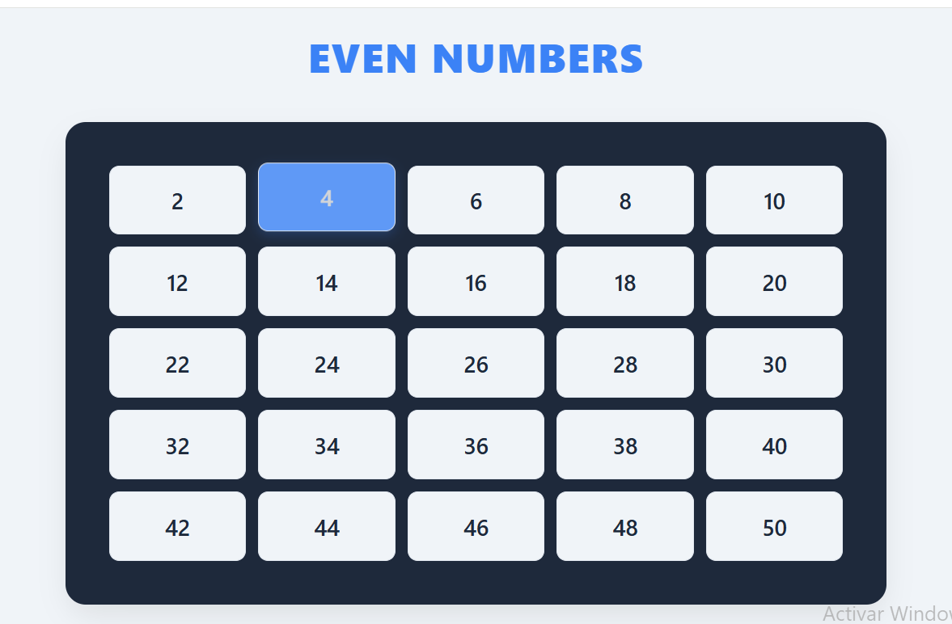
- EXTRA Include anything you need to do it as you see in the image
